Lecture 11 Voice Recognition
- Present applications http://electronics.howstuffworks.com/speech-recognition.htm
- Many users-small vocabulary
Voice-recognition phone systems are being used often now. They are limited in their vocabulary, but as such are quite accurate.
- Limited users-large vocabulary
Examples include voice to text for the handicap, and specific industries as for medical and legal establishment. Portable recorders are utilized and then entered in the computer and converted to text files by use of this s/w. Trained people entering text utilizing speech vs. keying have shown to have increased efficiency.

- How
- Hardware
Voice produces a varying air pressure. When applied to the microphone an analog signal is produced. That is a signal whereby the amplitude and the frequency continually change. The analog signal is then inputted to the sound card. The sound card has what is called an analog to digital converter (ADC). The signal is then sampled at a high continuous rate which produces a continuous stream of various amplitude pulses. The pulse amplitudes are then converted to a binary number. The greater the sampling and the more places in the binary number the more accurate the digital representation of the voice becomes.
- Software
The voice rec s/w analyzes the sampled signals and compares to a data base of patterns to determine what is called the smallest unit of language called phonemes. The phonemes are like a simple sound such as the h in hat. There are 44 phonemes in the English language. See http://jan.ucc.nau.edu/dsc27/Resources/Phoneme%20List.doc
Other languages have different amounts of phonemes. The patterns don’t always match exactly because of the variance of the individual producing them. The one selected is dependent using probability of the most likely one and the context of previous words and phonemes.
- Problems
- Different dialects and accents.
- Variations in speech speed.
- Signal to noise ratio (Surrounding environment and in the electronics).
- Homonyms (words that sound alike but are spelled differently)
- Similar sounding phrases
“I scream” or “ice cream”
“Recognize speech” or “wreck a nice beach”
- Multiple users speaking at the same time.
- CPU power to select from an incredible amount of possibilities

- Accuracy
Speech Recognition systems are commonly evaluated by computing the Word error rate (WER).
Word error rate can be computed as:
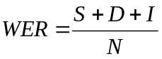
where
- S is the number of substitutions (a word typed is different than the one dictated)
- D is the number of the deletions (a word that was dictated did not show up in the typed document)
- I is the number of the insertions (an extra word that was not dictated came up in the document)
- N is the number of words in the correct section that was dictated.
- Future
  - Robots that can actually understand
  - Intelligent rooms and houses
  - A computer that can converse intelligently
  - Universal translator

- Dragon Naturally Speaking Software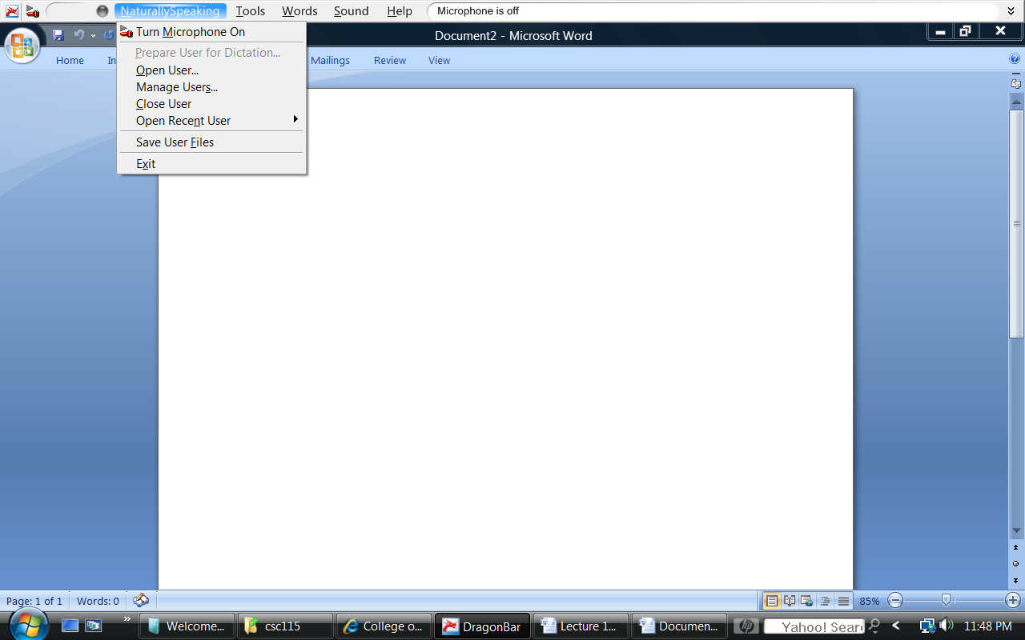

Dragon Pad 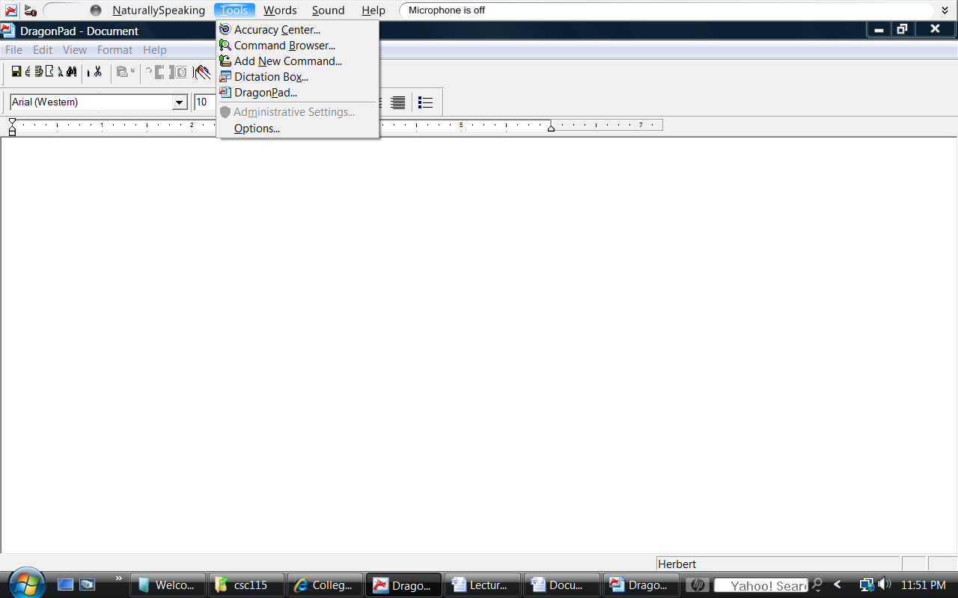
Beginning to type
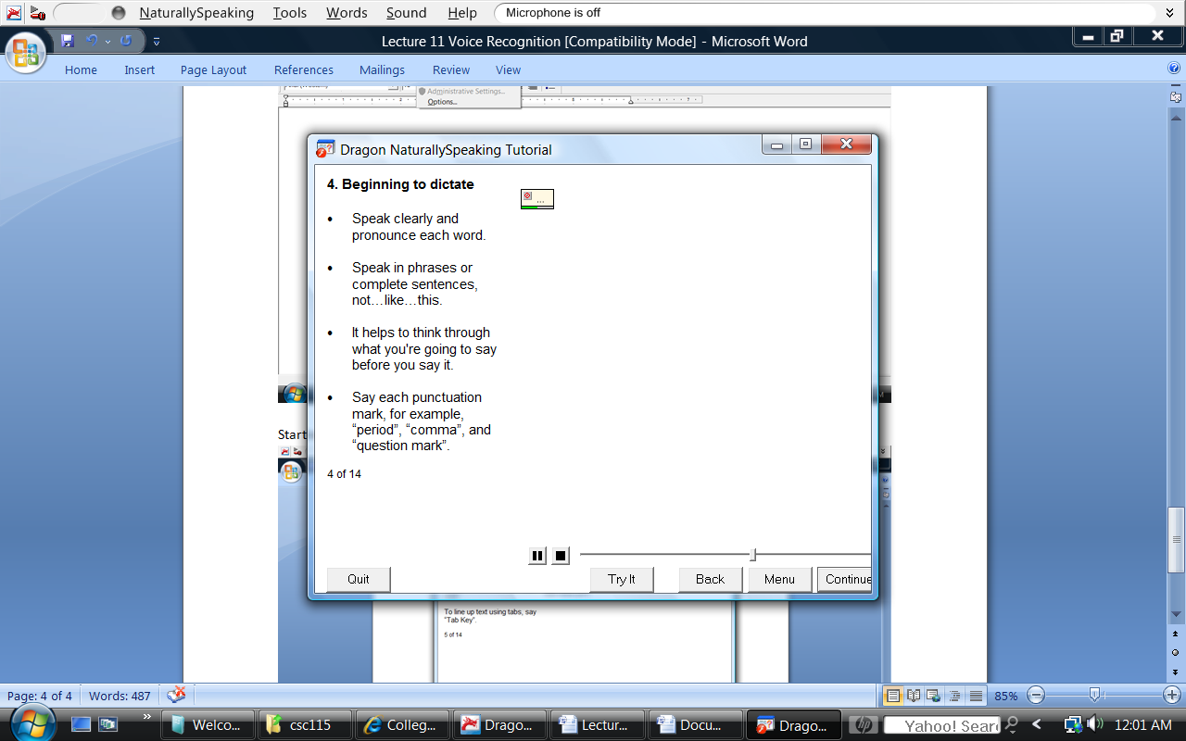

Starting a new paragraph, line, or tab
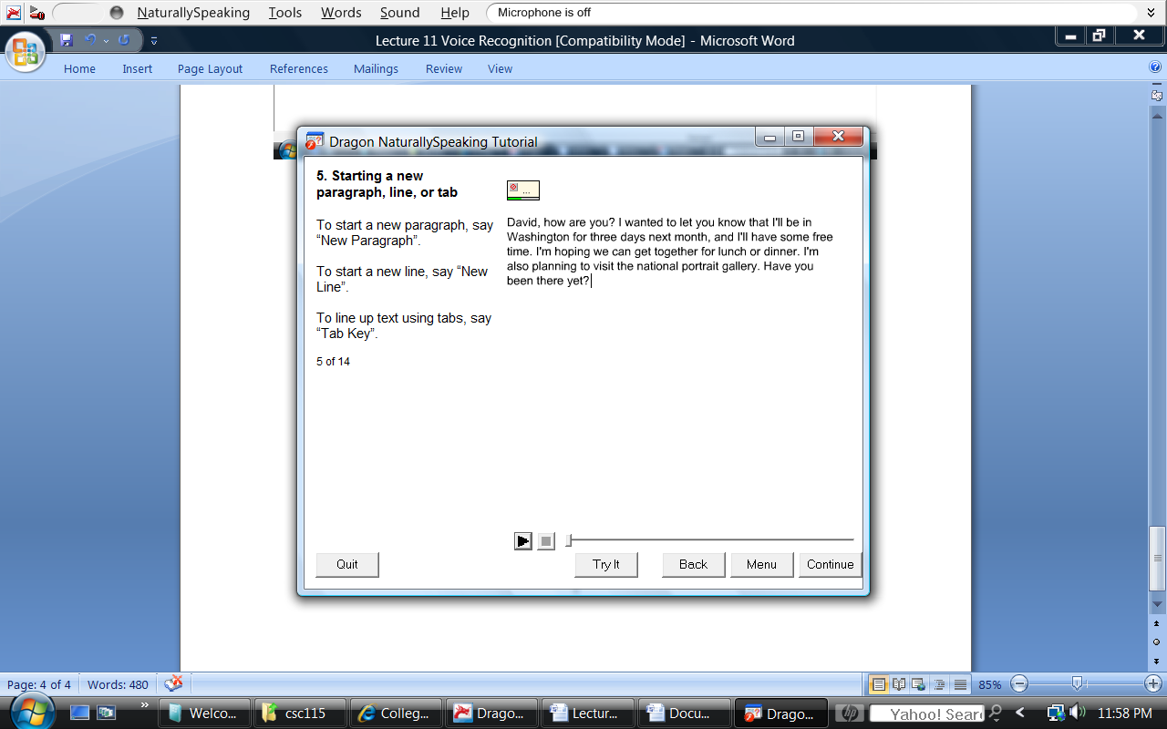

Commands
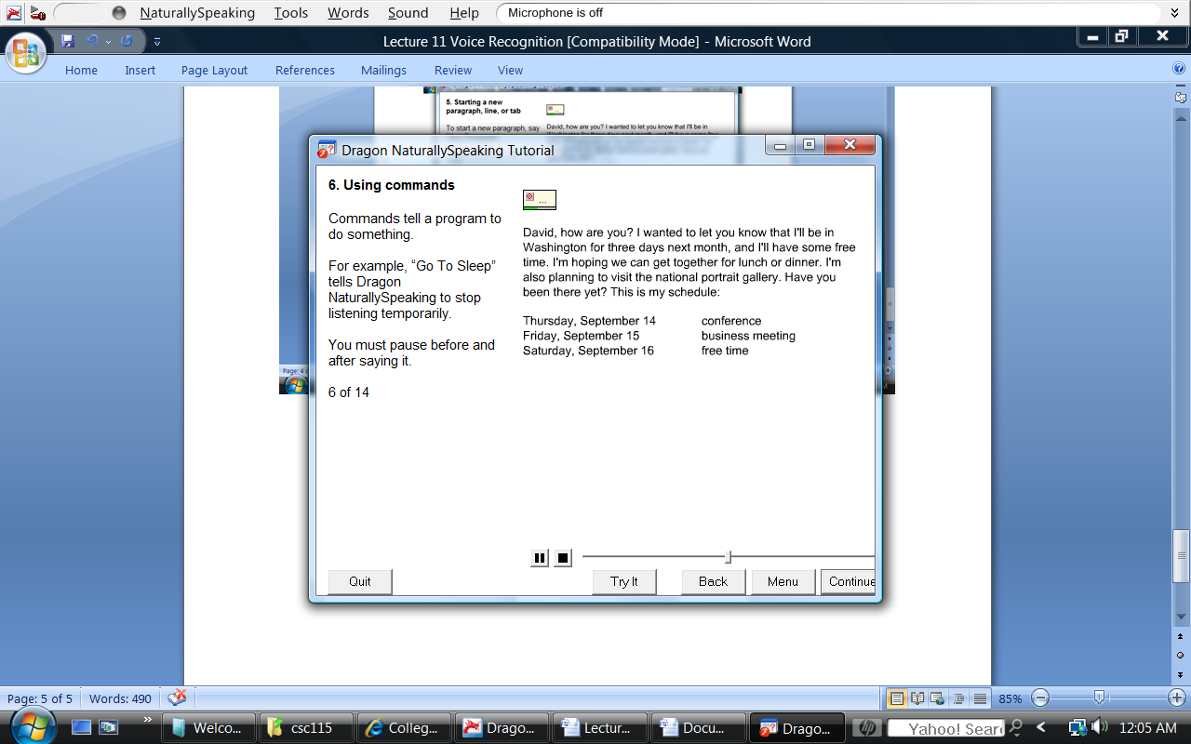

Select
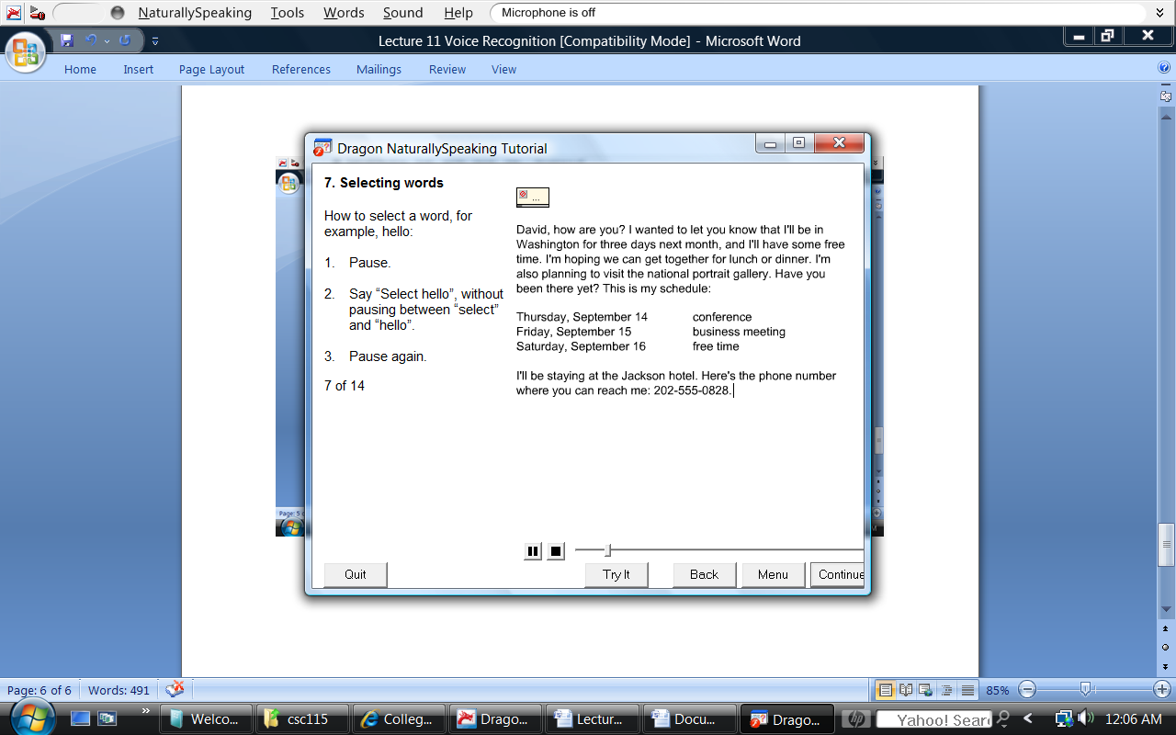

Select and Correct
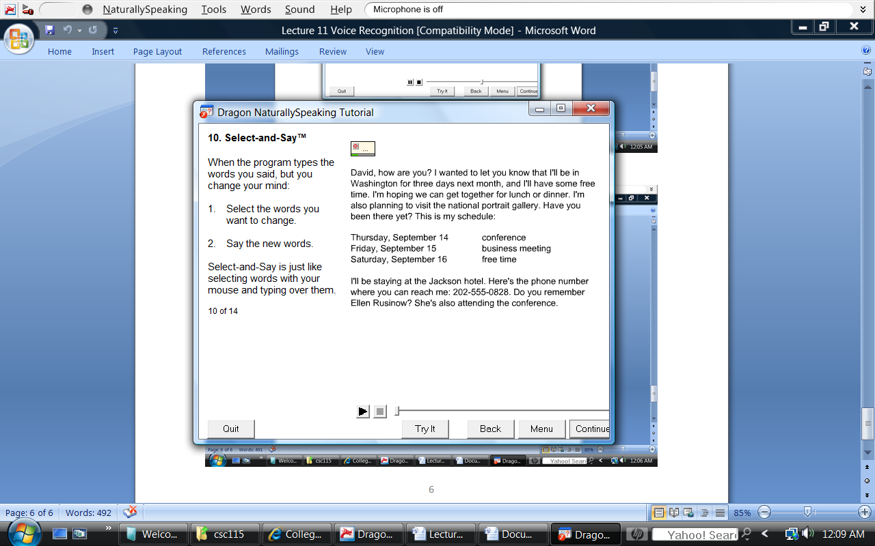

Deleting Characters
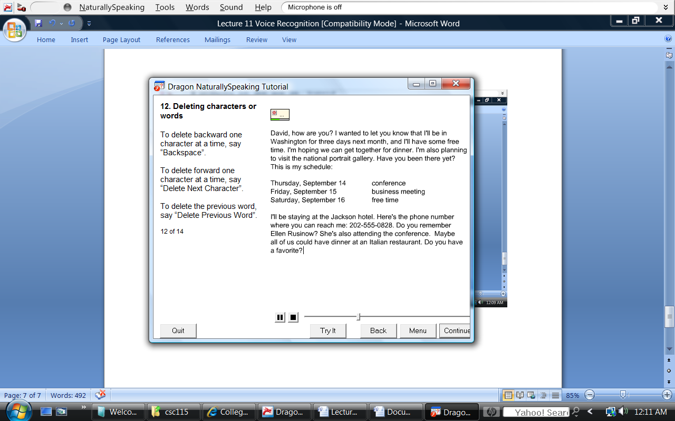
Formatting
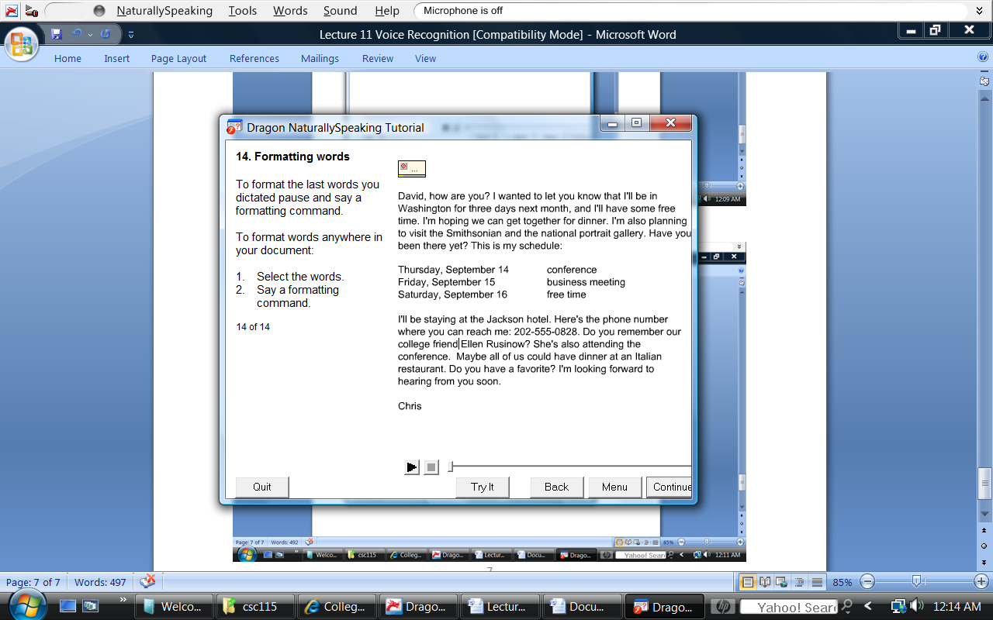
Cap that
Bold that
Underline that
Italics that

Software Applications
Word
Excel
Notepad
.
>
>

